

Personal Lines

Workflows & Procedures

*for*

Acrisure Digital Solutions, LLC

# How to Use this Document

|  |
| --- |
| This document contains valuable information relevant to the usage of EPIC, including **Epic Basics**, day-to-day **Workflows**, and **Job Aids. DO NOT PRINT THIS DOCUMENT.**  For optimal usage:   * Click the **View** menu at the top in the Microsoft Word toolbar * Checkmark **Navigation Pane**      * The left pane will open and show a listing of topics      * Click on the topic to jump to that section/page. * Hyperlinks within the document will lead to specific pages or Job Aids.      * Some hyperlinks will connect to a webpage outside of the document. |

# Epic Browser

## Logging in

|  |
| --- |
| 1. Open a web browser.    1. Chrome    2. Edge 2. Enter URL:    1. **Production/Live**: <https://acris03.appliedepic.com/#/>    2. **Test/Training**: <https://ve061t1web.appliedepic.com/#/> |

## Add the URL as a bookmark in the Chrome or Edge Browser

|  |  |  |
| --- | --- | --- |
| 1. In the browser URL address field, enter <https://acris03.appliedepic.com/#/>; press the keyboard enter key 2. Add to Bookmarks/Favorites as follows:  |  |  | | --- | --- | | **CHROME**    Click the star icon  Enter a name for the bookmark; click Done | **EDGE**    Click the star icon  Enter name and add to Favorites Bar; click Done | |

## Browser Tabs

|  |
| --- |
| Browser tabs will open at the top when accounts are located and selected    Use browser tools like Tab Grouping and Zoom, if desired.  To prevent connection issues, close out of a client by clicking the X above the Logout button, NOT the x in the browser tab |

## Connection Suite & New Functionality Popups

|  |
| --- |
| The Connection Suite is required to ensure full functionality and connection within Epic Browser. Acrisure IT manages all updates in the background for the Connection Suite Plugin. **Ignore these popups.** If you are receiving an error, follow the instructions to hard shutdown to ensure there’s a clean connection to all services run on your computer. If you are experiencing functionality issues after shutting down, submit a ticket to [support@acrisure.com](mailto:support@acrisure.com).  ***Reminder: A hard shut down of your computer should be done at the end of each workday.*** |

## Logging out of Epic

|  |
| --- |
| **\*\*IMPORTANT\*\***  When **closing out of Epic,** click the **LOGOUT** button at the top right in the blue Options Bar. **Do not X out.** Epic will not close properly which may cause issues when signing back in again.  **NO** |

**Shutting Down Desktop**

|  |  |  |  |  |  |  |
| --- | --- | --- | --- | --- | --- | --- |
| **\*\*IMPORTANT\*\***  Log out of Epic and SHUT DOWN your computer **at the end of each workday.**   |  |  | | --- | --- | | 1. Shut down the computer by clicking the Start Menu in the bottom left-hand corner of your desktop |  | | 1. Click Power |  | | 1. Click Shut Down |  | |

# EPIC BASICS

## Epic Icons

|  |  |  |  |
| --- | --- | --- | --- |
|  | Add New |  | Change column width |
|  | Edit |  | To define a search |
|  | Print list view |  | Executes search. These are cumulative. To begin a new search, click “Clear Filter” |
|  | Sortable column – ascending/descending |  | The logout button will close all open windows. If any screen requires validation (the process isn’t complete), the screen with display prior to closing |
|  | Change the order of items | **RIGHT CLICK** | Right clicking on a selected policy, activity or contact will often generate the same menu options as found in ACTIONS. |
|  | Collapses and opens sections of screen or moves full list from one screen to another |  | Click on the Paperclip to attach documents saved in Epic (Email) |
|  | Required Field – must complete |  | Click on the File to attach files saved on a local or network drive (Email) |
|  | Desired Field – agency would like field completed |  | Contacts in EPIC (from email) |
|  | Customize columns displayed in the list view |  | Contacts in Outlook (from email) |

## Keyboard Shortcuts

|  |
| --- |
|  |

## Home Base

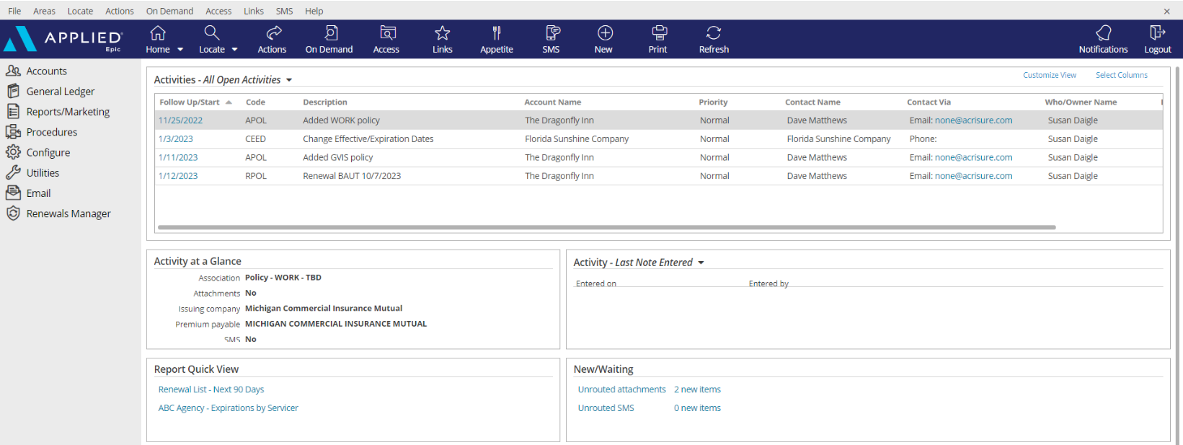

|  |
| --- |
| 1. **Open Activities** (suspense, follow up, to-do list)    * Use “**Select Columns**” to add columns to your view.    * The position of the columns can also be changed by clicking and dragging the column headers to the desired location.    * Sort columns in ascending or descending order by clicking on the column header 2. **Activity at a Glance** – displays information about the highlighted activity 3. **Activity Tasks** OR **Last Note Entered** – when a task within an activity is assigned to you, the task will appear here but only if the activity above, associated with the task, is highlighted. The view can be changed from “Activity – Tasks” to “Last Note Entered” by clicking the dropdown arrow and selecting the appropriate option. 4. **Report Quick View** – Created reports can be sent to Report Quick View for easy access. Just click the link and the report will open. Data displayed is in real time and will be refreshed as of the date it is opened 5. **New/Waiting** – If your agency has opted to use Front End Scanning, scanned mail can be accessed by clicking the “Unrouted Attachments” link. The number of items in your “inbox” will also display. 6. **Navigation Panel** – Items listed here will direct you to distinct parts of Epic or to the client’s account. Items available will change depending on which screen is being utilized. This is known as the “View” panel. 7. **Blue Options Bar** – Each icon contains action options, which will change depending on which screen is being utilized. Think of this as the “Do” bar. 8. **Log Out button** – Clicking this button will close all the open screens/windows and log out of Epic. 9. **Locate** – Click the dropdown arrow to see a list of the last 20 accounts accessed |

## Email

### Microsoft Outlook Integration with Epic

#### Set Outlook Email Integration Default

|  |
| --- |
| ***Setting Outlook as the Email Integration Option will allow the launch of Outlook from Epic. Emails sent from Epic will automatically attach to the client’s account and will also add a Sent Item in Outlook.***  ***This integration applies to emailing from Attachments or from any of the blue email links within a client’s account. This does NOT apply to the Distribution Manager.***   1. From the Home Base, click **Configure** from the left Navigation Panel 2. Click **User Options** and select **Email** 3. Select the Outlook radio button      1. Click **Finish.** |

### Configuring Attach to Epic Plug-In in Outlook

|  |
| --- |
| 1. Open Microsoft Outlook 2. Find **Attach to Epic** in the ribbon and click the down arrow next to the word **Applied**      1. Select Browser 2. Enter the Applied Epic Browser URL 3. Choose a Default Browser      1. X out of this window |

### Email from Distribution Manager

#### Set up Distribution Manager Email Account

|  |
| --- |
| 1. From the **Home Base**, click **Configure** from the left Navigation Panel 2. Click **User Options** and select **Distribution Email Accounts** 3. If more than one account is listed, **delete all except Primary Email Account**      1. Highlight Email Account and click the **Edit** pencil 2. Enter the Distribution Email Details as follows    * Associated Agency = select your Agency from the dropdown list    * Display Name = enter your full name    * Reply address = enter your email address 3. Mail Server Settings    * Check the box to Use external mail server    * Enter your email address 4. Click **Finish**   ***NOTE: For those whose legal entity name is being retained (Public Entity, Financial Services, etc.) it is important NOT to use the Acrisure email address; use your legal entity’s email address.*** |

#### Set up Distribution Email Signature

|  |
| --- |
| 1. From **Outlook**, Copy your email signature (Right Click/Copy or CTRL+C) 2. Go back to EPIC 3. From the **Home Base**, click **Configure** from the left Navigation Panel 4. Click **User Options** and select **Distribution Email Accounts** 5. With your DMS email account highlighted, click the edit pencil 6. Click the **Email Signature** tab 7. Click the **Add** button (+) 8. Enter a **Description** for your signature and check the **Default** box      1. In the white space below the format buttons, paste the email signature which was copied in Step 1 above (Right Click/Paste or CTRL+V) |

#### *If Acrisure Logo does not paste appropriately follow the steps below*

|  |
| --- |
| 1. Right click your Acrisure logo from your email signature inside of outlook and click Save as picture.      1. Go back into Epic, Click to Highlight box where logo should appear. 2. Select Insert/Edit Image Button 3. Search for Logo saved to your computer      1. Once Logo is selected click Open, then Click blue Ok button. 2. Resize Acrisure logo as needed. 3. Click **Finish** 4. The email signature will now be listed    Click Finish. |

#### Send Email from Distribution Manager

|  |
| --- |
| As part of the normal workflow, when the ACORD form is ready to print/send, utilize the **Distribution Manager** to send documents.   1. From the **Distribution** Tab, set delivery option to **Email** 2. The **From** field defaults to your email address, however the sender can be changed 3. Add **Signature** (should default) 4. Add more than one recipient, cc, or bcc 5. Enter body of the email with full HTML functionality (change font size/color, add logos, pictures, change alignment, etc. 6. If the documents need to be sent to multiple recipients, Click on **“To”** Button      1. Contact Address Book will open. Double click on the Contact Name to add as an additional recipient. Once all additional recipients are added, click **Finish.** |

## Faxing

### From Distribution Manager

|  |
| --- |
| As part of the normal workflow, when the ACORD form is ready to print/send, utilize **Distribution Manager** to send documents.   1. From the **Distribution** Tab, set delivery option to **email** 2. Select a “**From**” email address 3. In the “**To**” field, type **fax=1[fax number]@faxfinder.acrisure.com** 4. Enter **Subject** line (required) 5. Enter message, if needed      1. Click **FINISH** to send. |

## Sticky Notes

|  |
| --- |
| 1. Add a sticky note by clicking the **NEW** button in the blue Options Bar within the Client Account      1. Enter note 2. Collapse the note by clicking the double up arrows 3. Manage the Sticky Note by clicking the three vertical dots      1. Delete the Sticky Note by clicking the X 2. Add a New Sticky Note by clicking the + |

## Activities

|  |
| --- |
| Activities in Epic perform three essential functions:   * Add a record to the client file to reflect an action was performed. * Allow a follow up or Open Activity serves as a reminder to do something at a current or future date * Permanently documents the file with the use of Notes within Activities   ***NOTE: Activities or Notes in an Activity cannot be moved to another account*** |

### Home Base Open Activities

|  |  |
| --- | --- |
| **Select Columns** | Check or uncheck the columns desired to reflect within the Home Base View |
| **Customize View** | Allows the addition of other Employee activities to reflect within your own open activities list (if given permission) |
| **Right Click to Manage** | * **Close Activity** – *follow up action is completed* * **Add Note** – *add notes related to the process which is still pending* * **Add Task** – *assign a portion of the activity process to someone else to work on* * **Change Follow-up Date/Time** – *if the deadline for completing the activity can be moved* * **Change Who/Owner** – *reassign the activity for someone else to take care of, will move selected activity to their Home Base* * **View All Notes** – *Read all notes related to a specific activity process*      * **Take Ownership** – *If the activity is assigned to another person or a work group, it can be reassigned to yourself*   ***Note: multi-select activities (CTRL + Click) to apply the above actions to multiple activities at one time*** |

### Activity Access Levels

|  |  |  |  |  |
| --- | --- | --- | --- | --- |
| |  | | --- | | **Description** | | Accounting | | Financials | | HIPAA | |

### Activity Workgroups

|  |  |  |  |  |  |  |  |  |  |  |  |  |  |  |  |  |  |  |  |  |  |  |  |  |  |  |  |  |  |  |  |  |  |  |  |  |
| --- | --- | --- | --- | --- | --- | --- | --- | --- | --- | --- | --- | --- | --- | --- | --- | --- | --- | --- | --- | --- | --- | --- | --- | --- | --- | --- | --- | --- | --- | --- | --- | --- | --- | --- | --- | --- |
| |  |  | | --- | --- | | **Code** | **Description** | | @APPAY | Applied Pay Default Work Group | | @LEADS | Leads Inbox Default Work Group | | @EXT | External Default Group | | AAS | AAS Servicing | | ACCT | Accounting | | ACCTMW | ACRISURE MW1 ACCT ONLY - Accounting Midwest Team Only | | ACRINV | Acrisure Invoicing Team | | ARVW | Accounting Review | | CIDT | ACRISURE Centralized Interface Download Team | | DBSC | Direct Bill Service Center | | FLATWR | Flatworld Group | | INVO | Invoicing | | RENGRP | QUI Renewal Group | | CLSG | CL Service Group | |  |  | |  |  | |  |  | |

### System Generated Activity Codes

|  |  |  |
| --- | --- | --- |
| **Code** | **Description** | **Event** |
| **@APY** | Applied Pay payment received from &ContactName& | Payment from Client |
| **ACLM** | # Added claim for DOL &DateLoss& | Add Claim |
| **ADD1** | # Add Insured &AcctName& | Add Account |
| **ADD2** | # Add Prospect &AcctName& | Add Account |
| **ADDC** | # Address Applied to Other Items | Address Applied to Other Items |
| **ADJR** | # Adjust Receipt | Adjust Receipt |
| **ADSC** | # Add Service | Add Service |
| **AOP** | # Add Opportunity | Add Opportunity |
| **APOL** | # Added &PolType& policy effective &PolEffDate& | Add Policy |
| **AUID** | # Issued auto ID card | Issue Auto ID Card |
| **BIND** | # Issued binder &PolDesc& &PolEffDate &Policy#& | Issue Binder |
| **BND1** | # Bind Policy via Master Marketing | Move Marketed Lines to Current Policies |
| **BORP** | # BOR P&C - Agent Received Date: | Add Policy |
| **CCTI** | # Change Client Type To Insured | Change Client Type |
| **CCTP** | # Change Client Type to Prospect | Change Client Type |
| **CEED** | # Change Effective/Expiration Dates | Change Effective/Expiration Dates |
| **CERT** | # Issued Certificate ( &OintNm& ) | Issue Certificate |
| **CHGA** | # Audit &ServSumEffDate& &ServSumDesc& | Endorse/Revise-Existing Lines |
| **CHGE** | # Change &ServSumEffDate& &ServSumDesc& | Endorse/Revise-Existing Lines |
| **CHGI** | # Internal Correction &ServSumEffDate& &ServSumDesc& | Endorse/Revise-Existing Lines |
| **CHGL** | # &ServSumEffDate& &ServSumDesc& | Endorse/Revise-Add Line Midterm |
| **CPOL** | # Canceled - Lost Policy Eff: &ServSumEffDate& &ServSumDesc& | Cancel Policy/Line |
| **CREW** | # Canceled - Rewritten Policy Eff: &ServSumEffDate& &ServSumDesc& | Cancel Policy/Line |
| **ESIG** | # Send to eSignature | Send to eSignature |
| **EVID** | # Issued Evidence of Insurance &PolDesc& &PolEffDate& | Issue Evidence of Insurance |
| **PROP** | # Proposal Generated | Proposal |
| **RCER** | # Renewed COI | Renew Certificate of Insurance |
| **REIN** | # Reinstated policy/line | Reinstate Policy/Line |
| **RESC** | # Renew Service | Renew Service |
| **REVI** | # Renewed EOP | Renew Evidence of Insurance |
| **RPOL** | # Renewal &PolType& &PolEffDate& | Renew Policy |

### Manual Activity Codes (F9)

#### For Accounting Workflow Activities – See [SharePoint](https://acrisure.sharepoint.com/:w:/s/ACR-ABSAccountingTeam/ESAdZgcBwPdJt0_n5-hNILkBueeqZpQWrGK6rg54rr9l7g?e=4LVSdM&clickparams=eyJBcHBOYW1lIjoiVGVhbXMtRGVza3RvcCIsIkFwcFZlcnNpb24iOiI0OS8yMzExMzAyODcyNCJ9) for Platform Activity Guide

#### Personal Lines Workflow Manual Activities

|  |  |  |
| --- | --- | --- |
| **Code** | **Description** | **When to Create Activity** |
| **GACR** | Acrisure Real Estate Services Referral | Created by an Account Executive or Account Manager to track when a Real Estate Referral is Received |
| **GACS** | Acrisure Cyber Services Referral | Created by an Account Executive or Account Manager to track when a Cyber Services Referral is Received |
| **GAPT** | Appointment with &AcctName& | Created when an Appointment is made with a Client |
| **GCAL** | Call from &AcctName& | Created when a general call or email is received. |
| **GCN1** | Carrier Notice of Cancellation |  |
| **GCN2** | Carrier Notice of Cancellation for Non-Payment |  |
| **GNRN** | Policy Not Renewed | Created to attach the notice or communication of a client policy not being renewed. |
| **GXFL** | Ex-date follow-up for &AcctName& | Created to reach out to the client in the future to win back their business |
| **PAPR** | PL - Appraisal | Created when an Appraisal is received |
| **PARV** | PL – Account Review | Created when an Account Review is initiated |
| **PBIQ** | PL - Billing Inquiry | Created when a Billing Inquiry is received |
| **PBND** | PL Bind Request to Carrier | Created when a Bind Request is to be sent to the carrier. |
| **PCIQ** | Coverage Inquiry | Created when a Coverage inquiry is received from the client or an additional interest. |
| **PCN1** | PL - Carrier Notice of Cancellation |  |
| **PCN2** | PL - Notice of Cancellation for Non-Payment |  |
| **PCRF** | PL - Refer Claim to Claims Team | Created when a Claim is referred to our Internal Claims Team |
| **PEOP** | PL - EOP Request | Created when an Evidence of Property is Requested from our client or an additional interest. |
| **PLCR** | PL - Loss Control Recommendation | Created when a Loss Control Program is created for the client. |
| **PMT3** | Payment - SWEEP |  |
| **PMT4** | Payment |  |
| **PMVR** | PL - MVR Request | Created when we receive an MVR Request. |
| **PNCO** | New PL Client Onboarding | Created when we are Onboarding a New Client to our Agency |
| **PPCK** | PL - Policy Checking | Created for Checking Policy Shell information for accuracy after adding, renewing, or endorsing a policy. |
| **PRSK** | Account At Risk | Created for review of an Account at Risk. |
| **PUND** | PL - Underwriting |  |
| **QNEW** | Quote - New Business | Created for documentation during the new business quoting process |
| **QREW** | Quote – Renewal/Rewrite | Created for documentation during the rewrite quoting process |

## Attachments

### Adding Attachments and Documents by Dragging & Dropping into Epic

|  |
| --- |
| 1. Drag & Drop from Outlook, Network folder, or Desktop into Epic 2. Attach all Documentation to the corresponding ACTIVITY   ***NOTE: When creating initial activity, it is Best Practice to attach Activity to the Policy level. If there is no Policy when Activity is created, attach Activity to the Account level.***    Check the Client Accessible box to make an attachment available in the client portal (CSR24)  Remove description and update using Platform Naming Convention  Use this feature to quickly find important documents such as policy dec pages, audits, endorsements, or other important documents.  Select the appropriate access level for security |

### Attach using Add Attachment Button located in Attachment area:

|  |
| --- |
| 1. Click the **ADD** Button (+)    1. Select **Existing File** (from outside of Epic (i.e., local or network drive))    2. Select **Document** to access the Form Letter library    3. Select **eForm** to add a form filler ACORD form from the eForms library |

### Add Attachments and Documents using Attach to Epic Plug–In

|  |
| --- |
| **Attaching New Email Using Attach to Epic Plug-In**   1. Click **NEW Email** Button in Outlook 2. Checkbox **Attach to Epic** Box 3. Add Client Email Address in the To Field, Type Title in Subject Line and Type out body of email. When finished with email and all relevant documents are attached, click **SEND**. 4. Attach To tab will open in Browser 5. Click Magnifying Glass to the right of the Code Field to Locate Client. Click **Finish** Once Account is found. 6. Under Attach To – Identify and select the appropriate dropdown (Policy or Activity) for where the Email and/or documents should be attached to. 7. Once all required fields are completed, Click **Finish** and email will be routed into Applied.   **Attaching Existing Email Using Attach to Epic Plug-In**   1. Highlight or right click existing email in Outlook and select Attach to Epic 2. Attach to Tab will open in Browser 3. Click Magnifying Glass to the right of the Code Field to Locate Client. Click **Finish** Once Account is found. 4. Uncheck Box the **“Delete original after attaching”** box   ***NOTE: If this box does not get un-checked, your email will be deleted from outlook.***     1. Under Attach To – Identify and select the appropriate dropdown (Policy or Activity) for where the Email and/or documents should be attached to. 2. Once all required fields are completed, Click **Finish** and email will be routed into Applied. |

### AI Email Summarization

|  |
| --- |
| Let Epic’s AI Email Summarization tool add activity notes while simultaneously attaching your email.   1. Drag your document to & release on an activity *(either open to full details or in list view)*    1. Select **Summarize** to summarize a thread    2. OR check the box to include **Latest Message Only** and then select **Summarize** 2. The summarized notes will auto-populate and should be reviewed to confirm the results are valid and as expected *(you may add, delete or amend the notes as needed)* 3. Complete your attachment **Description,** select appropriate folder *(if not defaulted)* 4. **Finish**   **A screenshot of a computer  Description automatically generated** |

### Attachment Access Levels

|  |  |  |  |  |  |  |  |  |
| --- | --- | --- | --- | --- | --- | --- | --- | --- |
| Access levels allow restriction of access to attachments by granting security rights to certain groups.  The default Access Level = Public   |  |  | | --- | --- | | **Access Level** | **Description** | | 1 | HIPAA | | 2 | Accounting | | 3 | Management | |

### Attachment Actions

|  |  |
| --- | --- |
| Click **ACTIONS** | * **Convert to PDF** – *Converts any document to PDF format in two clicks; can also combine multiple documents into one PDF document* * **Distribute Attachments** – *Uses Distribution Manager to email documents to client contacts* * **Edit Attachment Detail** – *Edit description, association, access levels, and folder* * **Move Attachment** – *Move attachment to another account, folder, etc.* * Policy Checking (Do Not Use) * **Reactivate Attachment** – *Used to remove an attachment from the Inactive area* * **Send via CSIO eDelivery –** NOT APPLICABLE * **Send to eSignature** – *Launches DocuSign* * **Send Via Email** – *Emails attachment through Outlook* |

***PLEASE FOLLOW THE ATTACHMENT NAMING CONVENTION PROTOCOL*** ***JOB AID******.***

### Finding and viewing attachments/documents

|  |
| --- |
| * **Important Policy Documents:** In the attachments list view, click the link “Show Only Important Policy Documents” to view all documents being previously marked as “Important”   To revert to all documents, click “Show All Documents.” This link serves as a filtering tool.     * **Filters:** Choose a filter: Ex. Attached within last 6 months.     Filtering by multiple Types of Business is also an option and can be set as the filter default |

### Folder Structure

|  |  |  |  |  |  |  |  |  |  |  |  |  |  |  |  |  |  |  |  |  |  |  |  |  |  |  |  |  |  |  |  |  |  |  |  |  |  |  |  |  |  |  |  |  |  |  |  |  |  |
| --- | --- | --- | --- | --- | --- | --- | --- | --- | --- | --- | --- | --- | --- | --- | --- | --- | --- | --- | --- | --- | --- | --- | --- | --- | --- | --- | --- | --- | --- | --- | --- | --- | --- | --- | --- | --- | --- | --- | --- | --- | --- | --- | --- | --- | --- | --- | --- | --- | --- |
| |  |  |  | | --- | --- | --- | | Property & Casualty | Applications |  | | Audits |  | | Auto IDs |  | | Bind Requests |  | | Binders |  | | Cancellations |  | | Certificates |  | | Change Requests |  | | Claims | Claim Correspondence | | Claim Invoices | | Claim Payments | | Estimates | | Loss Notice | | Loss Runs | | Photos | | Correspondence |  | | Evidence of Insurance |  | | Inspection Reports/Loss Control |  | | Marketing |  | | MRV’s |  | | Policies | All Other Policies | | Auto | | Liability | | Property | | Workers Compensation | | Policy Checking |  | | Proposal |  | | Renewal |  | | Schedules |  | |

### Folder View

|  |
| --- |
| * Use folders to organize client documents (Optional) * Folder structure is pre-determined by Acrisure * To see documents in folders, click Attachments view and select Folder View from the drop-down list * Select the folder (i.e., Correspondence, Invoices, Policies, etc.) * Click the expander in the left panel to see sub folders |

### Form Letter Templates

|  |
| --- |
| To select a form letter:   1. Click the Attachments area in the Client account 2. Click the **ADD** button (+) 3. Select Document – click Continue      1. Select a **Template Folder** (i.e., Personal) 2. Select the form letter from the dropdown list      1. Under the Contact tab, check the recipient of the letter 2. Click the Policy/Claim tab and select a policy or claim to reference in the letter      1. Click **Continue** 2. Change attachment description if needed 3. Click **FINISH** 4. Epic data will merge with Microsoft Word and letter will open 5. Update letter as needed. When finished, click the X at the top right to close the Word document 6. Click **YES** to save document as an attachment 7. The Attachment will be saved in WORD format; however, if sending the letter via email or to eSignature, be sure to Convert to PDF first, as follows:    1. Right Click on the WORD attachment    2. Select “Convert to PDF”    3. Click **FINISH** 8. From the attachments area, find the PDF version of the form letter, right click and either “Send to eSignature” for DocuSign, or “Send Via Email” to send from Outlook.    1. If “Send Via Email” an attachment screen will pop up. The description can be changed for the email attachment if needed. |

### Access Filter

|  |
| --- |
| The Access button will filter items for a specific policy, activity, transaction, within the **Client’s Account**  **Example:**   1. From the policy screen, select a **policy** 2. Click the **Access** button 3. Select an option:    * **Activities** = displays all the activities associated with the selected policy    * **Attachments** = displays all the attachments associated with the selected policy    * **Claims** = displays all the claims associated with the selected policy    * **Opportunities** = displays all the sales opportunities associated with the selected policy    * **Services** = displays all the services associated with the selected policy    * **Proofs** = displays all the Proofs associated with the selected policy    * **Transactions** = displays all the transactions associated with the selected policy    * **Auditing** = displays all the documents a client has access to via the CSR24 Portal    * **Notifications** = displays notifications related to the selected policy   ***Note: Use the Access button to filter attachments, Example: Highlight policy, Access/Attachments, and only the attachments associated with the policy will appear.*** |

## Client Accounts

### Servicing Roles

|  |  |  |  |  |  |  |  |
| --- | --- | --- | --- | --- | --- | --- | --- |
| **External Service Team** | |  | | --- | | Acrisure Service Center | | Carrier Service Center | | GA - Emerson Reid | | GA - Martin Insurance Services * | | GA - PGM * | | GA - Suvaun * |   **When an account and/or policy is managed by an external service team (the Acrisure Service Center, a Carrier Service Center, or a General Agent on the EB side), select the appropriate Service Team from the drop-down list.**  **Note:**  **An Acrisure-owned GA will be indicated with an asterisk.** |
| Carrier Marketing |
| P&C Producer 1 |
| P&C Producer 2 |
| P&C Servicer 1 |
| P&C Servicer 2 |
| P&C Claims |
| Other Custom |
| Surety Producer |
| Surety Servicer |
| EB Producer 1 |
| EB Producer 2 |
| EB Servicer 1 |
| EB Servicer 2 |
| EB Claims |
| Non-Insurance Product Sales |
|  |

### Locate Account

|  |
| --- |
| * Click the **Locate** button to **search** for existing clients   **Locate Options:**   * + **Account/Business Name** – *contains full or partial account name*   + **Claims: Additional Party** – by involvement type, name, or phone number   + **Insurer Claim#** - must be exact & complete   + **Internal Claim#** - must be exact & complete   + **Date of Loss** – *range*   + **Last name, first name** – *begins with* and will search account detail name field and individual contacts   + **Lookup Code** – *begins with*   + **Phone Number** – must be exact & complete   + **Policy #** - *contains*   + **Prior Account ID** – *begins with* (from your prior system)   + **Relationship** – relationship type and then account name   + **Submission ID** – *begins with* (in marketing)   + **Vehicle Registration Number** * Click the **Locate** button to **add new** client accounts. * Click the **drop-down arrow** on the Locate button to access the last 20 accounts accessed (includes client accounts, employee accounts, company accounts, etc.) |

### Close Out of an Account Record

|  |
| --- |
| Locating and selecting an account will create a new tab in the browser. **Close the account record by clicking the X above the Logout button** NOT by clicking the x within the tab itself. |

## Contacts

### Contacts Overview

|  |  |
| --- | --- |
| **Individual Contact** | This is an additional individual contact (person) on the account. By choosing an individual contact, additional fields are made available, such as date of birth, SSN, marital status, driver's license number, etc. Click the lock to the right of the PII fields to secure the field, making it private. |
| **Primary Contact** | This is an **individual contact** that should be selected as the primary contact for the account. To make a contact **Primary,** click **ACTIONS** **> Change Primary Contact**. The Primary Contact is displayed in the Rolodex Card on the bottom left corner of the client’s account. |
| **Category** | Contacts are categorized based on their relationship to the Account: Contact Only—Policy Only—Both Contact & Policy |
| **Description** | Add **Description** to best represent the position or role of the contact (i.e., owner, manager, etc.) Select the appropriate description(s) for each Contact. This information is used for tracking and reporting. |
| **Classifications** | **Be sure to select** the appropriate contact classification. DM=Decision Maker; PC=Primary Contact   |  |  | | --- | --- | | __User - Benefits Technology | 06-June Birthday | | __User - CSR24/Portal | 07-July Birthday | | __User - HR Portal | 08-August Birthday | | __User - Indio | 09-September Birthday | | _Commercial (DM) | 10-October Birthday | | _Commercial (PC) | 11-November Birthday | | _Cyber (DM) | 12-December Birthday | | _Cyber (PC) | 401k Plan Administrator | | _EB (DM) | Acrisure Webinars | | _EB (PC) | Better Business Bureau Member | | _EB Compliance | Chamber of Commerce Board Member | | _EB Compliance Newsletter | Chamber of Commerce Member | | _EB Eligibility Contact | City Council Member | | _EB HRLS Compliance Summit | Driver - Church Van | | _EB Plan Admin | Driver - Commercial Account | | _HR Leader | Economic Development Board Member | | _Personal (DM) | Golfer | | _Personal (PC) | Homebuilders Association Member | | _Risk Management (PC) | International Traveler | | _Safety (PC) | Licensed Contractor | | _Work Comp (DM) | Licensed Electrician | | _Work Comp (PC) | Licensed Pilot | | 01-January Birthday | Licensed Plumber | | 02-February Birthday | Non-smoker | | 03-March Birthday | Smoker | | 04-April Birthday | Tax Authority | | 05-May Birthday | Tourism Commission Board Member | |

### Add Additional Contacts

#### Add Individual Contact

|  |
| --- |
| 1. From the client’s account, click **Contacts** in the left panel 2. Click the **ADD** button      1. Select the **Individual** radio button 2. Enter First Name, Last Name 3. **Category:** Indicate whether contact only, policy only, or both contact & policy 4. **Description:** Select the appropriate description for this contact 5. Enter the address. If the account address is the same as the contact address, check the box for Use Account Address 6. Enter phone number (indicate if mobile) and email address - ***NOTE: Email is a required field***. If the contact does not have an email address, enter [none@acrisure.com](mailto:none@none.com)      1. Click **DETAIL** to add preferences and personal information such as date of birth, SSN, License Number, etc.   Click **Save Contact**. |

## Policy Basics

### Policy Types

|  |  |  |
| --- | --- | --- |
| **CODE** | **DESCRIPTION** | **APPLICATION DETAIL** |
| PANI | PER Animal Mortality | < None > |
| PARA | PER Roadside Assistance | < None > |
| PAU1 | PER Automobile | Personal Auto Detail |
| PAU2 | PER Automobile - Antique/Collector | Personal Auto Detail |
| PAU3 | PER Motorcycle | Personal Auto Detail |
| PAU4 | PER Recreational Vehicle | Personal Auto Detail |
| PAU5 | PER Golf Gart | < None > |
| PAV1 | PER Aircraft | < None > |
| PBR | PER Builders Risk | Residential Section - Homeowners |
| PCON | PER Condominium | Residential Section - Homeowners |
| PDF1 | PER Dwelling Fire | Residential Section - Dwelling Fire |
| PDF2 | PER Dwelling Fire - Farm | Residential Section - Dwelling Fire |
| PDIC | PER Difference in Condition | Residential Section - Homeowners |
| PEQ1 | PER Earthquake (HO) | Residential Section - Homeowners |
| PEQ2 | PER Earthquake (DF) | Residential Section - Dwelling Fire |
| PEQU | PER Equine | < None > |
| PFL1 | PER Flood (NFIP) | Flood Insurance Preferred Risk Policy Application |
| PFL2 | PER Flood (Private) | < None > |
| PFL3 | PER Flood - Excess | < None > |
| PHO1 | PER Homeowners | Residential Section - Homeowners |
| PIM | PER Inland Marine | Inland Marine Detail |
| PLIA | PER Personal Liability | Residential Section - Homeowners |
| PMH1 | PER Mobile Home | Residential Section - Mobile Home |
| PPET | PER Pet | < None > |
| PPKG | PER Personal Package | < None > |
| PSEV | PER Special Event (NR) | < None > |
| PTEN | PER Tenant | Residential Section - Homeowners |
| PTRV | PER Travel Accident | < None > |
| PUMB | PER Umbrella | Personal Umbrella Detail |
| PVAL | PER Valuable Articles and Fine Art | < None > |
| PW01 | PER Warranty - Automobile | < None > |
| PW02 | PER Warranty - Home | < None > |
| PWAT | PER Watercraft (Under 26') | Watercraft Detail |
| PWC1 | PER Workers Compensation | < None > |
| PWI1 | PER Wind (HO) | Residential Section - Homeowners |
| PWI5 | PER Wind (DF) | Residential Section - Dwelling Fire |
| PYAC | PER Watercraft (Over 26') | Watercraft Detail |
| R401 | 401k Referral | < None > |
| RACS | Acrisure Cyber Services | < None > |
| RODP | On Demand Pay Referral | < None > |
| RPA2 | Payroll Referral | < None > |
| RPEO | PEO | < None > |
| RPRP | Portable Retirement Plan Referral | < None > |
| RSLO | SMB Loan Referral | < None > |
| RTIT | Acrisure Title Referral (NR) | < None > |

### Policy Statuses

|  |  |  |
| --- | --- | --- |
| **CODE** | **DESCRIPTION** | **WHEN USED** |
| **NEW** | New | New policy |
| **NBR** | New - BOR | New policy acquired via BOR |
| **CNW** | Cancelled (New) | Cancelled policy when original policy status was NEW |
| **CRN** | Cancelled (Renewal) | Cancelled policy when original policy status was REN |
| **CRW** | Cancelled – Rewritten (Flat of Mid-Term rewrite) | Cancelled from original carrier and rewritten with another carrier |
| **X-N** | Not Renewed (New) | Policy went to term but did not renew – original status = NEW |
| **X-R** | Not Renewed (Renewal) | Policy went to term but did not renew – original status = REN |
| **REN** | Renewal | Renewed policy with same carrier |
| **REW** | Renewal - Rewrite | Policy rewritten with another carrier on renewal |
| **NX1** | Cross-Sell New (Small) | New policy cross sold within the Platform if Total Annual Account revenue is under $10,000 |
| **RX1** | Cross-Sell Renewal (Small) | Renewal of a cross sold policy if Total Annual Account revenue is under $10,000 |
| **NX2** | Cross- Sell New (Large) | New policy cross sold within the Platform if Total Annual Account revenue exceeds $10,000 |
| **RX2** | Cross-Sell Renewal (Large) | Renewal of a cross sold policy if Total Annual Account revenue exceeds $10,000 |
| **ZER** | Created In Error | Use when deprecating policy for conversion cleanup, etc. |
| **ZIN** | Info Only | Use for Info Only policies which are not active with any carrier |

### Select the Correct Issuing Company (ICO)

|  |
| --- |
| **When setting up a policy, it is critical to select the correct writing/issuing company. This selection will pre-fill the correct Billing Company (PPE).** |

### Select the Correct Broker Payable Contract

|  |
| --- |
| * **If the PPE is a Broker,** change the Premium Payable CA to BR and select the Broker from the dropdown list * Select the correct Payable Contract by clicking the dropdown arrow * **This step is critical to align accurate Accounting functions** |

### Service Summary Rows and Stages

|  |
| --- |
| Service Summary Rows **(SSR)** provide a chronological order of services provided to the account. Each service/action taken to a policy will be reflected in the service summary row in the order of most recent.  When viewing a policy in Epic it is essential to view the most recent Service Summary Row.  From the policy view screen in a client account click to highlight the policy. Once doing so the most recent Service Summary Row will highlight. To view a different service summary row, click to highlight.  **For example**: Service Summary #2 *will default to* display the policy details for the endorsement effective on the date noted on the Service Summary row. While Service Summary Row #1 *will not* reflect the added vehicle since Service Summary row #1 reflects the details of the policy when the policy term began.    ***NOTE: When viewing a multi-line package, highlight one of the lines under the policy header to view the Service Summary Row. The screenshot below indicates if CPK1 is selected, there are no SSR’s displayed.***    *Single click on a line of business then the most recent Service Summary Row will default.*  *See below.*    Having multiple Service Summary Rows to view, allows us to be able to see the policy details at any given date during the term. We can use these details to compare the changes made between one Service Summary Row and another. To compare Service Summary rows, go to Blue Options bar and click **ON Demand>Service Summary Comparison**  The list below explains what the various stages represent. ***It is imperative to be sure the correct status of the policy is representative of the current stage of the policy details.***   * **In Process** – Policy details are not complete, and the application is open for edits * **Submitted** – It has been sent to the carrier for action and the application or endorsement is now locked down * **Issued** - Policy or endorsement has been issued by the carrier or confirmation of coverage received from carrier * **Not Issued** – Use only if policy or endorsement has not been issued by the carrier and it was previously in submitted stage * **Cancelled** – Cancellation has been confirmed by the carrier * **Migrated** – One time use for conversion and simulates the stage of submitted |

### Change Policy Dates

|  |
| --- |
| 1. Select Policy 2. **ACTIONS** > Change Effective/Expiration Dates 3. Enter new dates (Note: Service Summary Row Dates may need to be updated as well)      1. Activity **CEED** - Change to Closed if no follow-up needed |

### Copy Policy

|  |
| --- |
| Use this workflow when a copy of an entire policy needs to be moved within the same account or to another account.   1. Highlight the policy needing to be copied 2. Click **ACTIONS > Copy Policy** 3. Choose: To Another Account - or - To Current Account 4. Enter the Lookup Code of the Other Account (if copying To Another Account) 5. Fill in structure and policy detail 6. Click Detail 7. Policy has now been copied. Enter additional details as needed. |

### Print Application

|  |
| --- |
| 1. With the policy selected, click **ACTIONS** **> Review Application** 2. Click the **Distribution** Tab    1. Select Print as the distribution method    2. Click the **Download & Print** button     Download will be added to your **Downloads Folder** on your computer. This will allow the documents to be printed locally or to be printed from the PDF file    ***NOTE: Do not use the PRINT button within the Options Bar – This function downloads and prints a watermarked “House Copy”*** |

### ACORD Application Prefills

|  |
| --- |
| Prefilled ACORD applications can be configured for your convenience (email [support@acrisure.com](mailto:support@acrisure.com))   * Use prefills to enter common information or agency standard limits/coverages * A prefill can then be added when a policy is created by clicking the dropdown list then selecting the appropriate prefill option      * Prefills can also be added while in the application (navigation panel is open to the policy form), then clicking Actions / Select Prefill. The Service Summary Stage must be - In Process – to perform this action |

### Multi-Year Policies

|  |
| --- |
| * The way multi-year policies are set up in Epic is dependent on when premium is billed/collected. * If premium is collected at policy inception for the entire policy term, add the policy with an expiration date showing the true end of the policy term.   *Example: Jane Smith has a three-year Liability policy. The carrier is collecting the full premium at the policy inception. If the client is being billed for the full three-year premium, the policy would be entered with an effective/expiration date of January 1, 2020, to January 1, 2023.*   * If premium is collected EACH YEAR on a multi-year policy, add the policy with a one year effective/expiration date. At the end of the first year, renew the policy and bill the second-year premium. The policy would continue to be renewed until the end of the multi-year policy term.   *Example: Michael Jones has a three-year Liability policy. The carrier is collecting a third of the premium for the first year, a third of the premium for the second year, and a third of the premium for the third year. The policy would be entered into Epic as an annual term (i.e., January 1, 2020, to January 1, 2021). At the end of the first year, the policy would be RENEWED, and* *the second third of the premium would be billed. Policy would need to be renewed each year for three consecutive years.* |

### Continuous Policies (policies which do not expire)

|  |
| --- |
| * **Personal & Commercial Policies**:   + If an Agency Bill or Direct Bill policy and expiration date is known, enter as reflected on policy or binding documents.   + If a true continuous policy (i.e., E&O, Tail Coverage, etc.) where expiration date is not known and policy changes are not expected, enter the expiration date as 9999.   + If policy changes are expected, enter policy as an annual term and renew from year to year until coverage ends. * **Individual Life & Health & Employee Benefits Policies:**   + If expiration date is known, enter as reflected on policy or binding documents/service contract.   + If expiration date is not known, enter expiration date with a 9999 year. * **Client Contracts/Fee Policy Types:**   + If a service contract/fee policy type and expiration date is known, enter expiration date as reflected on service contract.   + If a service contract/fee policy type and expiration date is not known, enter expiration date as a one-year term and renew annually until the contract is cancelled.   + This process would be continued until the carrier is no longer collecting annual premiums or is cancelled. |

# Acrisure Digital Solutions, LLC

|  |  |  |
| --- | --- | --- |
| **AGENCIES** | | |
| **1DS** | Acrisure Digital Solutions, LLC | |
| **AAF** | A-Affordable Insurance Agency | |
| **MPX** | MPX Insurance Services | |
| **BRANCHES** | | |
| **1DS** | Acrisure Digital Solutions, LLC | |
| **AAF** | A-Affordable Insurance Agency | |
| **MPX** | MPX Insurance Services | |
| **DEPARTMENTS** | | |
| **BND** | Bonds | All Policy Types = BO |
| **CLL** | Commercial - Large | $50k Rev + |
| **CLM** | Commercial - Middle | $5000-50K Rev |
| **CLS** | Commercial - Small | <$5000 Rev |
| **ILF** | Individual Life & Health | All Individual Policy Types |
| **PEL** | Personal Lines - Large | 1k Revenue + |
| **PEM** | Personal Lines - Middle | 250-1000 Revenue |
| **PES** | Personal Lines - Small | <250 Revenue |
| **REF** | Non-Insurance Referrals | Non-Insurance Products - PEO, ACS, Title Referrals |
| **SRV** | Services | Consulting HR & Consulting P&C |
| **PROFIT CENTERS** | | |
| **1DS** | ADS National | |
| **MPX** | New and Renewal | |
| **AAF** | New and Renewal | |

# EPIC WORKFLOWS

## New Business Workflow

|  |
| --- |
| **Procedure**:   * All leads received in Salesforce * Producer manages leads through Salesforce and is responsible for New Business Quoting * When policy sold, producer will issue in Salesforce * Servicer is notified of issued business then Servicer will sync new insured from Salesforce to EPIC. Servicer is looking for the EPIC look-up code to populate in Salesfoce * If sync does not work, **Add New Client** into EPIC * Once policy has been bound, then a **New Policy** will need to be added. |

### Add New Client

|  |
| --- |
| 1. Click **LOCATE** 2. Click the **Add** button (+) 3. **Add Account**    1. Select the **Individual** radio button    2. Type of Business = **Personal**      1. **Account Information**    1. **Client Type** –Insured    2. **Account Source** – Select from the dropdown list **(required field)**    3. **Structure** – Select Agency & Branch from dropdown lists      1. **Contact Information**    1. **Primary Contact**: Enter First Name, Last Name, Date of Birth    2. **Additional Contact**: Enter First Name, Last Name, Date of Birth (if applicable)    3. **Address**: Enter Street Address on first line (address verification tool will find the correct address and a pop-up will alert if any duplicate addresses are found)      1. **Phone**    1. Enter Type (i.e., Business, Mobile, Residence, etc.)    2. Enter Number (must include all 10 digits)    3. Permission – select from dropdown    4. **SMS** = check to enable this number for SMS Text Messaging    5. Click Yes to enable conversational SMS for this number      * 1. Click **+Phone** to add additional phone numbers      1. **Email**    1. Enter Primary Email address    2. Enter **Primary Contact Email** and **contact preferences**      1. **Agency Information**    1. **Agency Defined Categories** – predetermined by the agency; used to tag an account for a specific reporting purpose (i.e., to mark as a VIP account)    2. **Relationships** – add related accounts (i.e., account subsidiaries)      1. Click **Save Account**      1. **Activity**: **ADD2** (add Prospect) or **ADD1** (Insured)    1. Defaults closed    2. Add **Notes** (how account was acquired, what has been done for this account thus far, etc.)    3. Click **FINISH** 2. **Account Details**    1. Click the **Servicing Tab** and enter all applicable staff names within the Servicing Roles |

### Add Policy

|  |  |  |  |  |  |  |  |  |  |
| --- | --- | --- | --- | --- | --- | --- | --- | --- | --- |
| 1. Click **Policies** from the Navigation Panel (left) 2. Click the **ADD** button - select **Contracted** policy 3. Enter Policy Details:    1. **Select Policy Type** from dropdown list (click the Description header to sort by description)    2. **Policy Line** – description will default    3. **Policy number** – enter Policy Number or TBD if unknown    4. **Effective/Expiration date**: update as needed    5. **Source** – Choose from the drop down **(Required Field)**    6. **Agency = Choose Your Agency**    7. **Branch = Choose Your Branch**    8. **Department:** Select the department based on the **account** **revenue** size  |  |  |  | | --- | --- | --- | | PEL | Personal Lines - Large | $1,000 Rev + | | PEM | Personal Lines - Middle | $250 - $1,000 Rev | | PES | Personal Lines - Small | <$250 Rev |  * 1. **Status** = Select **NEW**   2. **Issuing Location** – verify   3. **Bill type**: Select Agency or Direct Bill   4. Select **Profit Center** = Select CORE **unless** the policy fits into a specific **practice group**  (Note: Options shown in the dropdown are based on Department selected)   5. **Issuing Company** – Select from dropdown list (Click description header to sort by Name)   6. **Premium Payable Entity** - Select from dropdown list (Click description header to sort by Name)      * 1. If PPE is a Broker, change **CA** to **BR** and enter broker name from dropdown list     **NOTE: Be sure to select the appropriate PPE Contract if BR is selected**     1. **Line Commission**: Enter carrier policy commission percentage. This can be found on the quote or carrier/broker invoice. **If not found on quote or carrier/broker invoice, use your best estimation. If completely unknown, enter 1%** 2. **Line estimated premium:** Estimate Annual Premium only (no taxes or fees). Enter premium quoted. 3. Hit the blue **Calculate** next to Commission and EPIC will calculate the commission.      1. Click **Detail** 2. **ACTIVITY:** Select **APOL**    1. Verify Who/Owner    2. Follow-up/Start Date    3. Add Notes    4. Click Finish 3. From the Navigation Panel, click **Servicing/Billing > Line**    1. **Pr/Br Tab (Required)**: Each policy requires at least one PPAY (NOTE: PPAYs are Employees; BPAYs are outside brokers)       1. If a Producer is getting paid commission on a policy, enter his/her name from the dropdown list.       2. When selected, their producer commission agreement will default          1. Be sure to enter 100% Production Credit (this is not commission related but gives the producer credit for booking the business written). **NOTE:** BPAYs never receive Production Credit    2. **Servicing Tab**: Verify Servicing Roles 4. **Non-Downloaded Policies** - Make sure to update Policy Detail in the left Navigation panel 5. Click the X on the left panel   11. Click – Yes Perform Action > **Update Stage to Submitted. C**lick **Finish**. |

#### Policy Received from Carrier

|  |
| --- |
| **DOWNLOAD:**   1. Downloaded policies will automatically update policy stage to Issued with the policystatus **- NEW.** 2. **ZNEW** activity will generate and is set to close automatically 3. Review **Daily Download Report** to view downloads received and the **Download Audit Report** to update policy/client record with missing information. 4. **Attach** policy dec to **APOL** in client's account. 5. Close the open **APOL** (from the Home Base) as successful   **NON-DOWNLOAD:**   1. Policy Check for accuracy: **Attach** policy dec to **APOL** in client's account. 2. If the Policy is NOT accurate, leave **APOL** open for follow up; send to carrier for correction. 3. From policy: **ACTIONS > Issue/Not Issue Policy** 4. Issue; enter/verify policy number; verify effective/expiration dates; verify estimated Premium. 5. Click **Close Open Activities** taband update **APOL** status to Closed   **\*Send Welcome Letter to Client**  Issue EPIC Auto ID Cards  Issue Evidence of Property Insurance  For Agency Billing Questions & Accounting Activities see [SharePoint](https://acrisure.sharepoint.com/:w:/s/ACR-ABSAccountingTeam/ESAdZgcBwPdJt0_n5-hNILkBueeqZpQWrGK6rg54rr9l7g?e=4LVSdM&clickparams=eyJBcHBOYW1lIjoiVGVhbXMtRGVza3RvcCIsIkFwcFZlcnNpb24iOiI0OS8yMzExMzAyODcyNCJ9) for Platform Activity Guide |

## Renew Policy Workflow

### Downloaded Renewals

|  |
| --- |
| * Review **Daily Download Report** to review downloads received and the **Download Audit Report** to update policy/client record with missing information. * Downloaded policies will automatically renew. The new term will be Issued, and the **status updated to REN.** * **ZREN** automatic closed activity * eDoc attached |

### Non-Downloaded Renewals

|  |
| --- |
| * Review upcoming renewal list * Receive & review new term policy dec – policy check from expiring * Renew policy in Epic – From expiring: **ACTIONS> Renew**   • Review details (policy number, effective/expiration dates, etc.)  • Policy status = **REN**  • Click Detail   * Select **RPOL** Activity - add notes, update follow up and status of activity. * Click **Finish**   • Make sure to update any Policy Detail on the left panel. This includes adding the **Estimated Line Premium** at the Line level and **Calculate** the **Commission**   * Close navigation panel>Update **Stage to Issued** * Select Finish * Attach dec pages to the **RPOL** Activity * If Renewal is complete and no follow up is needed close **RPOL** activity * If Renewal is not complete and follow up is needed leave **RPOL** activity open * Send copy of the policy documents to client (if not sent by carrier).   Issue EPIC Auto ID Cards  Issue Evidence of Property Insurance  For Agency Billing Questions & Accounting Activities see [SharePoint](https://acrisure.sharepoint.com/:w:/s/ACR-ABSAccountingTeam/ESAdZgcBwPdJt0_n5-hNILkBueeqZpQWrGK6rg54rr9l7g?e=4LVSdM&clickparams=eyJBcHBOYW1lIjoiVGVhbXMtRGVza3RvcCIsIkFwcFZlcnNpb24iOiI0OS8yMzExMzAyODcyNCJ9) for Platform Activity Guide |

## Rewrite/Remarket Policy Workflow

|  |
| --- |
| **Procedure:**   * When Rewriting/Remarketing a policy, the ***ACTIONS>Renew*** workflow is **required** to create a policy shell and to ensure the downloaded policy comes through properly. The below steps must be done **within 24 hours** of binding the policy with the carrier. |

### Rewrite/Remarket Renewal Policy Shell

|  |  |
| --- | --- |
| * Remarket to carriers via carrier website or Salesforce. * Use one manual **QREW** activity for each carrier quoted to document file and save attachments. Add Quoted Premium to activity amount and specify PPE within the Activity. * When Carrier is selected, Close **QREW** as **Successful.** Close **Unsuccessful** if Rewrite/Remarket is not taken.   **Renew Policy in EPIC**   |  | | --- | | **Policies rewritten from one carrier to a new carrier will use Actions > Copy Policy instead of Actions > Renew and the expiring carrier renewal download will need to be cancelled flat.**  **Copying the policy instead of renewing it will make sure the Rewritten policy is downloaded correctly. Confirming the expiring carrier renewal download is cancelled will remove the policy from Expiration and Potentially Missed Renewal reports.** |  1. Select **EXPIRING** policy term 2. Click **Actions > Copy Policy** 3. **Destination** – To current account 4. Verify **Structure** 5. **Policy Detail** 6. Description 7. Policy Number 8. Effective/Expiration Date 9. **Lines of Business** (if more than one line of business, each line needs to be updated) 10. Verify Line(s) of Business 11. Policy Status **REW – Rewrite** 12. Billing – **Agency** or **Direct** 13. Profit Center – Select from dropdown 14. Issuing Company/Premium Payable 15. **Line Commission –** Enter carrier commission percentage if known  * **If Commission is Unknown –** * Check the box to use commission agreement * Select the policy type with **Acrisure Estimated Rate** in the dropdown      * If commission agreements are **not** in dropdown; enter 1%  1. Click **Detail** 2. Policy Opens - Click **Servicing/Billing > Line** on left Navigation Panel 3. **Servicing** tab – Verify required Servicing Contacts 4. **Pr/Br Commissions** tab – Verify Commission Agreement 5. Click the **X** on the left Navigation Panel to close out of Policy Detail 6. If Policy has been Submitted to the Carrier for binding – Close Policy Detail > **Update Stage to Submitted** 7. Click **Finish** 8. When **Expiring** carrier has downloaded the renewal; proceed with one of the following options:  * Confirm for carrier Cancellation Download and update policy status to **CRW – Cancelled – Rewritten** * Follow the Cancellation Workflow to cancel the downloaded renewal flat. Policy status of **CRW – Cancelled – Rewritten** and utilize the **CREW** activity code if needed. |

### Policy Received from Carrier

|  |
| --- |
| 1. Policy Check for accuracy. Attach policy to **RPOL** 2. Processor will create a note when policy checking complete and will attachpolicy document to **Policy** in client's account (if not received via eDocs)   If policy NOT downloaded:   * 1. Highlight policy, click **ACTIONS > Issue/Not Issue Policy**   2. **Issue**; enter/verify policy number; verify effective/expiration dates   3. Click **Close Activity tab**:  close **RPOL** successful   If policy is downloaded:   1. The download will issue the policy and update detail 2. The open **RPOL** Activity will need to be closed manually   Issue EPIC Auto ID Cards  Issue Evidence of Property Insurance  For Agency Billing Questions & Accounting Activities see [SharePoint](https://acrisure.sharepoint.com/:w:/s/ACR-ABSAccountingTeam/ESAdZgcBwPdJt0_n5-hNILkBueeqZpQWrGK6rg54rr9l7g?e=4LVSdM&clickparams=eyJBcHBOYW1lIjoiVGVhbXMtRGVza3RvcCIsIkFwcFZlcnNpb24iOiI0OS8yMzExMzAyODcyNCJ9) for Platform Activity Guide |

## Policy Not Renewed Workflow

### Mark Policy as Not Renewed

|  |
| --- |
| * With the policy highlighted, press F9 (or click **NEW > Activity**) and select the **GNRN** Activity; add notes as to why the policy not renewed.   **Download:**   * Review **Download Report** and/or open **ZCAN** or **ZNON** activities. * Download will **automatically** update the: * Service Summary Stage to **Cancelled** * Policy Status to **Cancelled (Renewal)** * Policy status will need to be verify: from the left panel click Servicing/Billing > Line and update the policy status to: * **Not-Renewed – X-N or X-R** (select based on original status) * If **Lost** Policy - Close the **CPOL** and/or **ZCAN / ZNON**activity as **Unsuccessful** and select reason; add notes and click Finish * If **Rewritten** Policy – Close the **CREW** and/or **ZCAN / ZNON**activity as **Successful**; add notes and click Finish.   **Non-Download:**   * From the client’s account, click **Policies** from the left panel * Double click the policy which is not renewing * In the left panel, click **Servicing/Billing > Line** * Update the policy status to **X-N (Not-Renewed NEW) or X-R** **(Not Renewed REN)** (Select based on original policy status) * Click the X on the left panel * With the policy highlighted, press F9 (or click **NEW > Activity**) and select the **GNRN** Activity   + Add notes as to why the policy not renewed   + Mark as Closed – Unsuccessful; select reason * Click Finish |

## Policy Change Workflow

|  |
| --- |
| **Procedure:**   * After you have processed the change with the carrier online, process the change in Epic (enter an endorsement shell) to prepare for download. * If download, no need to enter updated policy detail **-** mark as **Update Stage to Submitted** * If **not receiving policy detail download**, enter all change detail in the ACORD form apps; then mark as **update stage to submitted.** * When non-downloaded endorsement received, Issue/Not Issue Endorsement and close open activity in the same process. |

### Process Change Request (Existing Line)

|  |
| --- |
| 1. Receive policy change request from client 2. In Epic – **ACTIONS > Endorse/Revise Existing Line;** enter:    1. Effective date of change    2. Description of change    3. Details    4. **Activity = CHGE**    5. Add detailed notes:  who called, what did they ask for, your responses or direction, etc.; click Finish   **Downloaded policies**:   1. Click the X in the left panel 2. Yes, perform action: **Update Stage to Submitted** 3. Process changes on carrier website 4. Attach bind confirmation, emails with client/carrier, etc. to the **CHGE** activity 5. Attach actual policy dec endorsement to the **Policy** in Epic   **Non-Downloaded Policies:**   1. Update ACORD detail in Epic to include the change requested 2. Prepare ACORD Change Request Form (if applicable) and/or email change to carrier    1. Attach email/change request to the **CHGE** activity    2. Leave Activity Open for follow up   Click the X on the left panel – Yes Perform Action > **Update Stage to Submitted.** Click **Finish**. |

#### Endorsement Received from Carrier

|  |
| --- |
| **Downloaded Policies:**   1. Review daily download list – review download audit report and update missing information 2. Close the **CHGE** activity. 3. Download will update the service summary row and **Issue** the endorsement   ***If Endorsement is incorrect, keep the CHGE open then send request back to the carrier or to servicer for correction. When received, check again, then close the CHGE activity.***  **Non-Downloaded Policies:**   1. Attach policy endorsement to the **CHGE** in Epic    1. Update Line Estimated premium on the policy  * Double click on policy * Under Servicing/Billing>Line; Update the Estimated Premium to show the Additional or Return premium.   Example: Current policy premium is $1,000. A change was made which increase the premium by $200. Change the Line Estimated Premium to $1,200   * Hit the blue **Calculate** next to Commission and the EPIC will calculate the commission.  1. Close the **CHGE** activity (add notes as applicable)    1. If Endorsement incorrect, keep the **CHGE** open and send request back to the carrier for correction. When received, check again, and close the **CHGE** activity.    2. Attach policy endorsement to the **CHGE** in Epic 2. From policy, **ACTIONS > Issue/Not Issue Endorsement** 3. Verify effective date of change and other details 4. Issue 5. Click **Open Activity** tab: Close the **CHGE** activity as successful; click Finish   **Issue Proofs:**  Issue EPIC Auto ID Cards  Issue Evidence of Property Insurance  For Agency Billing Questions & Accounting Activities see [SharePoint](https://acrisure.sharepoint.com/:w:/s/ACR-ABSAccountingTeam/ESAdZgcBwPdJt0_n5-hNILkBueeqZpQWrGK6rg54rr9l7g?e=4LVSdM&clickparams=eyJBcHBOYW1lIjoiVGVhbXMtRGVza3RvcCIsIkFwcFZlcnNpb24iOiI0OS8yMzExMzAyODcyNCJ9) for Platform Activity Guide |

### Process Change Request (Add Line Mid-Term)

|  |
| --- |
| **Process Change Request (Add Line Mid-Term)**   1. Receive policy change request from client 2. In Epic – **ACTIONS > Endorse/Revise Add Line Mid-Term;** enter:    1. Effective date of change    2. Description of change    3. Click the **ADD** (+) button within the Line of Business section    4. Add Line Code, Status, and Issuing Location    5. Verify Profit Center, ICO/PPE    6. Add Carrier Commission percentage if known **(if unknown add 1%)**    7. Click **Detail**    8. **Activity = CHGL**    9. Add detailed notes:  who called, what did they ask for, your responses or direction, etc.; click **Finish**   **Downloaded Policies:**   1. Process change on carrier website 2. Attach bind confirmation, emails with client/carrier, etc. to the **CHGL** activity 3. Click the X on the left panel to close out of the policy detail 4. Click Yes Perform Action > **Update Stage to Submitted**   **Non-Downloaded Policies:**   1. Update ACORD detail in Epic to include the change requested 2. Prepare ACORD Change Request Form (if applicable) and/or email change to carrier    1. Attach email/change request to the **CHGL** activity    2. Leave Activity Open for follow up    3. Click the X on the left panel – Yes Perform Action > **Update Stage to Submitted,** Action **> Submit Application** (if an Acord form needs to be sent to the carrier), or Perform Action > **Submit Change Request** to generate the Acord for distribution) click **Finish** |

#### Endorsement Received from Carrier

|  |
| --- |
| **Downloaded Policies:**   1. Review daily download list – review download audit report and update missing information 2. Close the **CHGL** activity. 3. Download will update the service summary row and **Issue** the endorsement   ***If Endorsement is incorrect, keep the CHGL open then send request back to the carrier or to servicer for correction. When received, check again, then close the CHGL activity.***  **Non-Downloaded Policies:**   1. Attach policy endorsement to the **CHGE** in Epic    1. Update Line Estimated premium on the policy  * Double click on policy * Under Servicing/Billing>Line; Update the Estimated Premium to show the Additional or Return premium.   Example: Current policy premium is $1,000. A change was made which increase the premium by $200. Change the Line Estimated Premium to $1,200   * Hit the blue **Calculate** next to Commission and the EPIC will calculate the commission.  1. Close the **CHGL** activity (add notes as applicable)    1. If Endorsement incorrect, keep the **CHGL** open and send request back to the carrier for correction. When received, check again, and close the **CHGL** activity.    2. Attach policy endorsement to the **CHGE** in Epic 2. From policy, **ACTIONS > Issue/Not Issue Endorsement** 3. Verify effective date of change and other details 4. Issue 5. Click **Open Activity** tab: Close the **CHGL** activity as successful; click Finish   **Issue Proofs:**  Issue EPIC Auto ID Cards  Issue Evidence of Property Insurance  For Agency Billing Questions & Accounting Activities see [SharePoint](https://acrisure.sharepoint.com/:w:/s/ACR-ABSAccountingTeam/ESAdZgcBwPdJt0_n5-hNILkBueeqZpQWrGK6rg54rr9l7g?e=4LVSdM&clickparams=eyJBcHBOYW1lIjoiVGVhbXMtRGVza3RvcCIsIkFwcFZlcnNpb24iOiI0OS8yMzExMzAyODcyNCJ9) for Platform Activity Guide |

## Cancel Policy Workflow

### Cancel Monoline Policy

|  |
| --- |
| 1. Locate Account 2. Select Policy 3. **ACTIONS > Cancel** 4. Select Policy Release 5. Enter Effective Date of Cancellation 6. Enter a description 7. Click DETAIL    * Activity: **CPOL-** Add notes (who, what, where, when how) or **CREW** if rewriting with a new carrier    * Click Finish 8. From the left panel, enter Reason/Method, Additional Interest, and Remarks as needed. 9. X out of Policy (from the left navigation panel) 10. To generate the Lost Policy Release, click **PRINT > Cancellation** 11. Select **Attach without Distributing** 12. From Attachments, right click on the LPR and select **send to eSignature** 13. Follow DocuSign workflow |

#### Signed LPR Received:

|  |
| --- |
| 1. DocuSign will send a verification email confirming the LPR was signed and will automatically attach the signed LPR to the Attachments area of the client’s account 2. Add notes to the **CPOL** or **CREW** Activity 3. **Option 1: Submit Cancellation request through Carrier Website**     * Enter cancellation on carrier website    * Select Policy and **ACTIONS** > **Update Stage to Submitted**—Click Finish   **Option 2: Submit Cancellation through Epic**   * + Select the signed LPR from attachments   + Right click and **Send Via Email** to the carrier   + Highlight the policy in question; then click **ACTIONS > Update Stage to Submitted**   + Add notes to the **CPOL** or **CREW** activity |

#### Cancellation Confirmation Received from Carrier:

|  |
| --- |
| **Download Policies:**   * Review **Download Report** and/or open **ZCAN** or **ZNON** Activity * Download will automatically update the: * Service Summary Stage to **Cancelled** * Expiration Date of Policy * Policy Status to **Cancelled (Renewal)** * Policy Status will need to be verified: From the left panel click Servicing/Billing > Line and update the **Policy Status** to**:** * **Cancelled – CNW or CRN** (select based on original status) * **Cancelled – Rewritten – CRW** (Cancel/Rewrite) * If **Lost Policy** - * If there **is** a **CPOL** activity – Close as **Unsuccessful** and select reason; add notes and click **Finish**. Close the **downloaded** activity as **Successful** to prevent duplication. * If there is **not** a **CPOL** and only a **ZCAN** / **ZNON** activity – Close as **Unsuccessful** and select reason; add notes and click **Finish**. * If **Rewritten Policy** – Close the **CREW /** **ZCAN / ZNON** activity as Successful; add notes and click **Finish**.   **Non-Download Policies:**   1. Select Policy then **ACTIONS** > **Issue Cancellation** – verify details 2. Policy Status will need to be verified: From the left panel click Servicing/Billing > Line and update the **Policy Status to:** 3. **Cancelled – CNW or CRN** (select based on original status) 4. **Cancelled – Rewritten – CRW** (Cancel/Rewrite) 5. Click the **Close Open Activity** tab and close the **CPOL** activity as **Unsuccessful** or **CREW** activity as Successful add notes, click **Finish**. Attach Cancellation Confirmation to **Activity.** |

### Cancel a Policy Line from a Package Mid-Term

|  |
| --- |
| 1. From the Client’s account, click **Policies** from the left navigation panel 2. Select the policy line to be cancelled; click **ACTIONS > Cancel** 3. If the client’s signature is required on a Lost Policy Release form, select Policy Release, otherwise, select Cancellation Request 4. Enter Effective Date of cancellation 5. Enter description as to why cancelling 6. **Uncheck all lines NOT being cancelled** and **check only the line that IS being cancelled** 7. Click **DETAIL** 8. Select **CPOL Activity** - change Description to reflect only the one line in the package policy being cancelled    1. Activity = Open for follow-up on receipt of cancel confirmation/endorsement from the carrier    2. Add notes as to why cancelling    3. Click **FINISH** 9. **Submit Cancellation request through Carrier Website**     * Enter cancellation on carrier website    1. Select Policy and **ACTIONS** > **Update Stage to Submitted**—Click Finish |

#### Cancel Confirmation Received from Carrier:

|  |
| --- |
| **Download Policies:**   * Review **Download Report** and/or open **ZCAN** or **ZNON** Activity * Download will automatically update the: * Service Summary Stage to **Cancelled** * Expiration Date of Policy * Policy Status to **Cancelled (Renewal)** * Policy Status will need to be verified: From the left panel click Servicing/Billing > Line and update the **Policy Status** to**:** * **Cancelled – CNW or CRN** (select based on original status) * **Cancelled – Rewritten – CRW** (Cancel/Rewrite) * If **Lost Policy** - * If there **is** a **CPOL** activity – Close as **Unsuccessful** and select reason; add notes and click **Finish**. Close the **downloaded** activity as **Successful** to prevent duplication. * If there is **not** a **CPOL** and only a **ZCAN** / **ZNON** activity – Close as **Unsuccessful** and select reason; add notes and click **Finish**. * If **Rewritten Policy** – Close the **CREW /** **ZCAN / ZNON** activity as Successful; add notes and click **Finish**.   **Non-Download Policies:**   1. Select Policy then **ACTIONS** > **Issue Cancellation** – verify details 2. Policy Status will need to be verified: From the left panel click Servicing/Billing > Line and update the **Policy Status to:** 3. **Cancelled – CNW or CRN** (select based on original status) 4. **Cancelled – Rewritten – CRW** (Cancel/Rewrite) 5. Click the **Close Open Activity** tab and close the **CPOL** activity as **Unsuccessful** or **CREW** activity as Successful add notes, click **Finish**. Attach Cancellation Confirmation to **Activity.** |
| **\*Important Notes:**   * **The Cancellation status will only show on the Service Summary Line of the policy to be cancelled. All other lines will show N/A because the change/cancellation did not affect the other package lines.** * **The expiration date will change only for the line of business for which the cancellation was requested. The policy expiration date will not change.** * **ON RENEWAL, remember to uncheck the cancelled line so it will not be included in the package policy renewal term.** |

### Notice of Cancellation for Non-Payment

|  |
| --- |
| **Notice of Cancellation for Non-Payment Received**   1. When NOC for Non-Payment is received, go to Policies area in the Client’s account 2. Click Policies in the left panel 3. Highlight the policy in question from the policy list view 4. Click the **NEW** button in the top blue options bar and select Activity (or press F9) 5. Select the **GCN2** activity      1. Update the Follow-up/Start date to the Date of Cancellation 2. Add Notes 3. Click Detail 4. Drag and Drop the Pending Cancel notice into this activity 5. Update the Attach To description in accordance with your Platform’s document naming conventions      1. Click **Finish** 2. Follow appropriate steps below based on whether the client did or did not make payment    1. If client makes payment by the due date, drag & drop the carrier Rescind Notice to the open PCN2 activity on the Home Base. Update the description according to the Platform’s naming conventions. Add to folder as needed.       1. Right click on the activity and select Close       2. Mark as **Successful**       3. Add Final note (i.e., Payment received – cancel notice rescinded)       4. Click **FINISH**    2. If client does not make payment by the due date, drag & drop the carrier Final Cancel Notice to the open PCN2 activity on the Home Base. Update the description according to the Platform’s naming conventions.  Add to Cancellation folder as needed.       1. Right Click on the activity, select Close       2. Mark as **Unsuccessful**       3. Add Final note (i.e., Payment not received by due date – carrier cancelled)       4. Click **FINISH**       5. Continue with Cancellation process |

## Policy Reinstated Workflow

### Reinstate Policy

|  |  |  |  |  |  |  |  |  |  |  |  |  |  |  |  |  |  |
| --- | --- | --- | --- | --- | --- | --- | --- | --- | --- | --- | --- | --- | --- | --- | --- | --- | --- |
| **Download:**   |  | | --- | | **Download will automatically amend your policy/line status to Renewal. If the original policy status was other than Renewal, status will need to be updated appropriately.**  **If a policy status is Cancelled, it will NOT show up on your expiration reports or create system generated renewal activities.** |      * Review **Download Report** and/or open **ZREI** or **ZRNR** activities. * Download will **automatically** update the: * Service Summary Stage to **Reinstated** * Expiration date to the original **Expiration Date** * Policy Status to **REN** - **Renewal** * Policy status will need to be verified: from left navigation panel click **Servicing/Billing > Line** and update the policy status to the appropriate “New” or “Renewal” option:  |  |  |  |  | | --- | --- | --- | --- | | **NBR** | New - BOR | **REN** | Renewal | | **NEW** | New | **REW** | Renewal – Rewrite (First renewal w/new carrier) | | **NX1** | New – Cross Sell – Under 10K | **RX1** | Renewal – Cross Sell – Under 10K | | **NX2** | New – Cross Sell – Over 10K | **RX2** | Renewal – Cross Sell – Over 10K |  * Mark task on **ZREI** or **ZRNR** as completed and close Activity as **Successful**, add notes and click Finish * If closed, reopen the **ZCAN / ZNON**Activity and close as **Successful**; add notes and click Finish. * If there is an original closed **CPOL or CREW** Activity; Reopen Activity, then close as **Successful**; add notes and click Finish.   **Non-Download:**   * From the client’s account, click Policies from the left panel * Select the CANCELLED policy to be reinstated * Click **ACTIONS > Reinstate** * Enter date the policy was reinstated * Add Description * Click Finish * Activity = **REIN**: Add detailed notes as to why the policy was reinstated   + Close Activity Successful; click Finish * Verify the Policy Status was updated correctly per the original Policy Status * If there is an original closed **CPOL** Activity; Reopen **CPOL** Activity then Close as Successful |

### Reinstate with Lapse – Non-Download

|  |
| --- |
| * From the client’s account, click Policies from the left panel * Select the CANCELLED policy to be reinstated * Click **ACTIONS > Reinstate** * Enter the date the policy was reinstated * Add Description – Reinstated with Lapse in coverage * Click Finish * Activity = **REIN**: Add detailed notes as to why the policy was reinstated   + Close Activity Successful; click Finish * Verify the Policy Status was updated correctly per the original Policy Status * If there is an original closed **CPOL** Activity; Reopen **CPOL** Activity then Close as Successful |

# JOB AIDS

## JA.1 Proofs of Insurance

### EPIC Auto ID Cards

1. Select Policy
2. **ACTIONS > Issue Auto ID Card**
3. Highlight the appropriate vehicle—make sure there’s a Y under the Issue Column or Click Select to Issue if not
4. Click the Distribution Tab
5. Select Contact (use magnifying glass to locate)
6. Select Via (Print, Email, Fax) and enter additional details
7. Click **Finish**—AUID Activity defaults closed

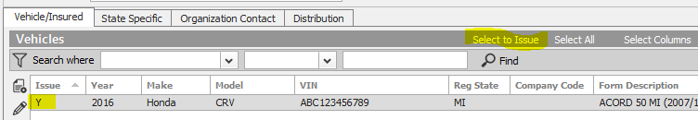

### EPIC Evidence of Property Insurance

#### Add New Evidence

1. Locate Account
2. Click the **NEW** button—Proofs > Evidence
3. Select the appropriate ACORD form; enter a Title
4. Under Type, select appropriate policy and service summary row
5. Click **Detail**
6. Click each section and enter details
7. When completed, click **ACTIONS** > **Issue Evidence**
8. Click the Additional Interest Distribution Tab
   * Select Contact (use magnifying glass to locate)
   * Select Via (Print, Email, Fax) and enter additional details
   * Click **Finish**
9. Click the X in the Navigation Panel to close the EPI

#### Renew Evidence

* + - 1. Locate Account
      2. Click Proofs of Insurance from the Navigation Panel
      3. Select Evidence
      4. Highlight the appropriate EPI
      5. Click **ACTIONS** > **Renew Evidence**
  + Select the renewal policy and service summary row
  + Select the lines of business to include
  + Check the defaults to include
  + Click **Detail**
    - 1. **Activity REVI** defaults closed—add notes, click Finish

#### Issue Single / New Additional Interest

* + - * 1. Locate Account
        2. Click Proofs of Insurance and edit appropriate EPI
        3. Highlight the additional interest—click the **ADD** button to add new AI and detail
        4. Click **ACTIONS > Issue Singe Additional Interest**
        5. Uncheck Insured if not needed. Verify AI distribution.
        6. Click **Finish**

## JA.2 DocuSign Integration

**From Attachments in the Client’s account**:

1. Right-click the attachment and select **Send to eSignature**

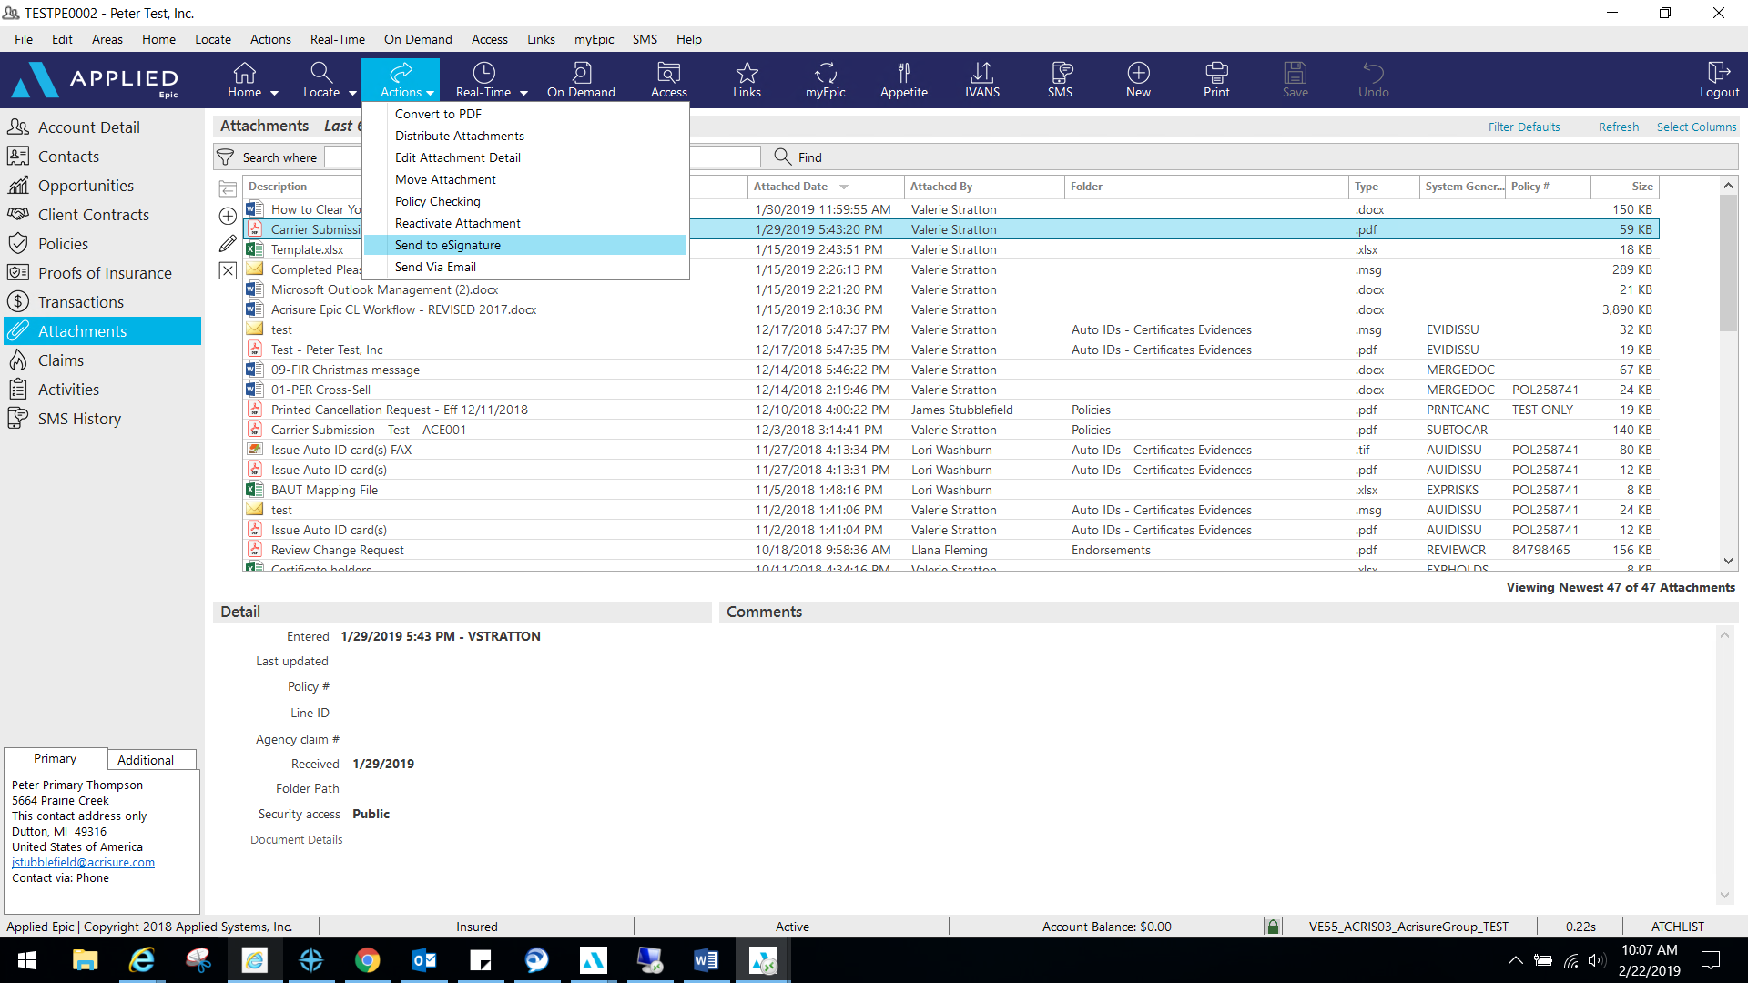

1. 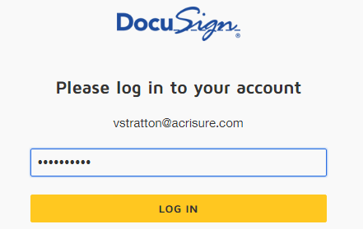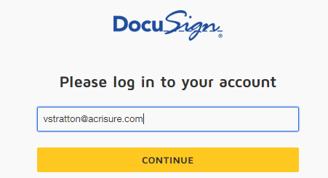Log into **DocuSign** using your email address and password.
2. Allow DocuSign permission to integrate with Epic.

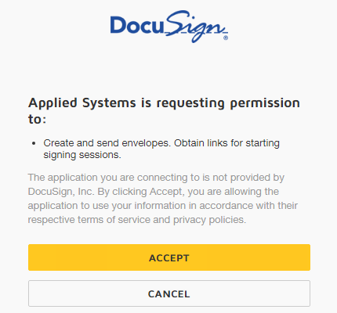

1. Select an Epic Contact; click the TO button

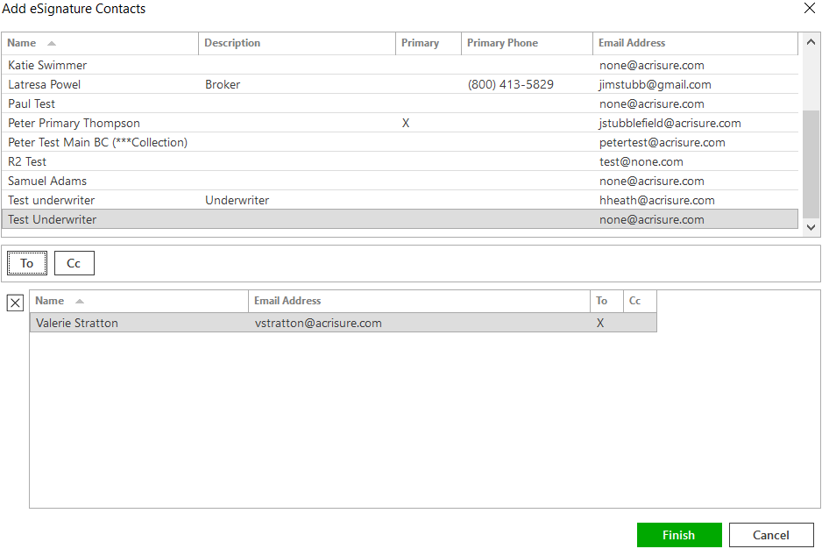

1. Please wait while Epic directs the document to DocuSign for signatures fields.
2. Add appropriate fields for signature, date, text, etc. by dragging and dropping onto the document.

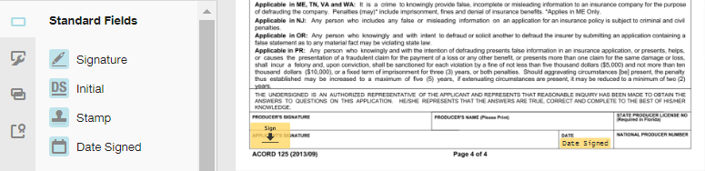

1. If using a template, remove the extra recipient. Actions>Edit Recipient

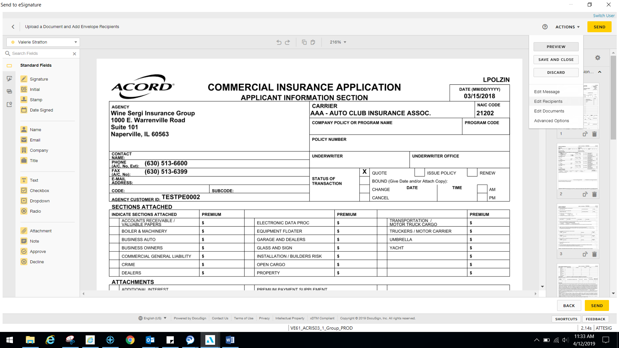

1. Once finished, select Actions>Edit Message.

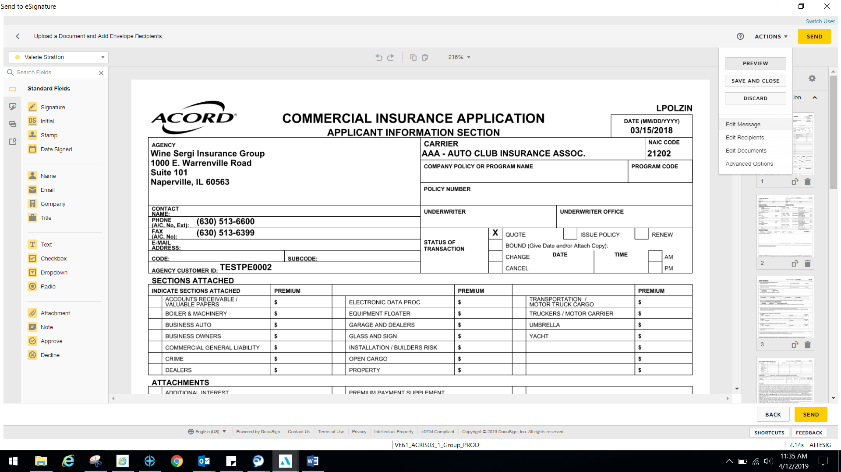

1. Edit the email subject line and personalized message to client and select Done.

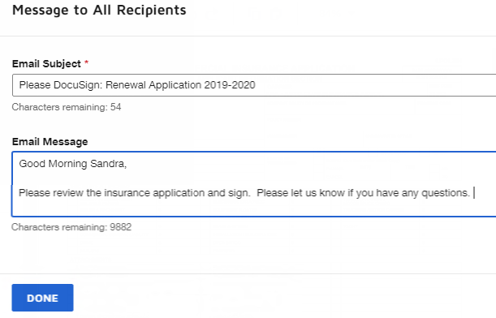

1. Select Send in the top right or bottom right corner when finished.

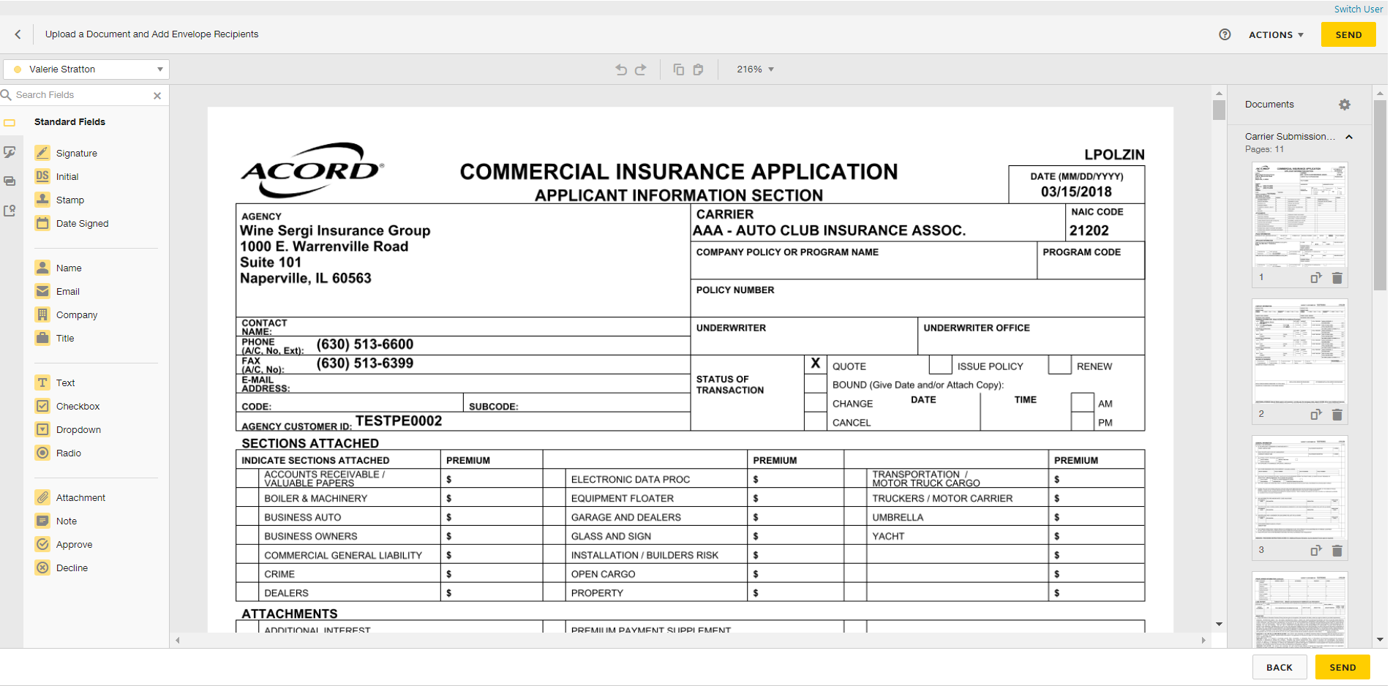

1. DocuSign will redirect you to sign into your account to manage your envelopes. Close out when finished.
2. **ESIG** will be the automatic activity generated once finished and will automatically remain open for follow up. Close **ESIG** as successful if there is another open activity related to this process.

## JA.3 Attachment Naming Conventions

|  |  |  |
| --- | --- | --- |
| **Document Type** | **Naming Convention** | **Example** |
| Renewal Policy - Select Middle Market CL Policy | YY-YY (Line of Business) Policy, Carrier, Effective Date, Premium | 23-24 General Liability Policy, Travelers Eff 6-29-2023 $500 |
| Renewal Policy - Non-Select Middle Market CL and all PL Policies | YY-YY (Line of Business) Policy, Carrier, Effective Date, Premium | 23-24 Auto Policy, Travelers, Eff 6-29-23, $1,000 |
| New Policy - PL | YY-YY (Line of Business) Policy, Carrier, Effective Date, Premium | 23-24 Workers Comp Policy, Travelers, Eff 6-29-22, $1,500 |
| New Policy -CL | YY-YY (Line of Business) Policy, Carrier, Effective Date, Premium | 23-24 General Liability Policy, Travelers, Eff 6-29-23, $20,000 |
| Endorsement to carrier | YY-YY (Line of Business) Endt (#) to(Carrier) Eff MM-DD-YY change description, | 23-24 Auto Endt to Travelers Eff 6-29-23 Adding 2024 Ford Explorer Vin (last 4)  23-24 General Liability to Fran @ Travelers Endt Eff 6-29-23 Amend Sales to $500,000  23-24 Home Endt to processing team Effective 6-29-23 Increase home limit to $550,000 |
| Cancellation Confirmation | YY-YY (Line of Business) Cancellation, Eff MM-DD-YY, Reason | 23-24 Auto Cancellation, Effective 6-29-23, Non-Payment of Premium |
| Audit | YY-YY (Line of Business) Audit, Carrier, AP/RP | 22-23 General Liability Audit, Travelers, RP $500 22-23 Workers Comp Audit, Travelers AP $1,500 |
| Intent to Cancel | YY-YY (Line of Business) Intent to Cancel, Eff MM-DD-YY, Carrier, reason | 23-24 General Liability, Intent to Cancel, Eff 6-29-23 IPFS, non-payment of premium 23-24 Auto, Intent to Cancel, Eff 6-29-23 Travelers, Underwriting - MVR John Smith |
| Nonrenewal Notice | YY-YY (Line of Business) Non-Renewal Notice, Eff MM-DD-YY, Carrier, reason | 23-24 Auto Non- Renewal Notice, Eff 6-29-23 Travelers, no longer a market |
| Reinstatement | YY-YY (Line of Business) Reinstatement Eff MM-DD-YY | 23-24 Auto Reinstatement Eff 06-29-23 |
| Quotes | YY-YY (Line of Business) Quote Carrier, Quote $ | 23-24 Workers Comp Quote, Hartford, $500 |
| Applications | YY-YY (Line of Business) Application, Carrier (to be Completed, signed etc.) YY-YY (Line of Business) Application, Carrier (completed, signed etc.) | 23-24 Auto Application Travelers, to be completed/signed 23-24 General Liability Hartford Contractor Supp completed and signed |
| Carrier Submissions | YY-YY (Line of Business) Submitted to (Carrier) | 23-24 General Liability, Auto Umbrella Submission to Mike@Hartford |
| Endorsement Received | YY-YY (Line of Business) Endt (#) received Eff MM-DD-YY change description AP/RP | 23-24 General Liability, Endt #5 received, Eff 5-1-23 amending sales to $500,000 AP $1,000 |
| Emails |  | Request to Sam/Insd for information on 2012 Ford |
| Request to Jim/Liberty/UW request for MVR information |
| Quotes |  | 23-24 Auto Quote Liberty |

## JA. 4 Referral Workflow (Real Estate, Cyber, PEO, Payroll, etc)

|  |
| --- |
| * Referrals and related correspondence will be documented with Activities in the Epic system * Whenever a Referral is given to the Real Estate or Cyber division at Acrisure, or any outside carrier or vendor where we get a share of commission or referral fee, a policy need to be set up to receive the renewal commission. |

#### Manual Activity and Policy Types

|  |  |  |  |  |  |  |  |  |  |  |  |  |  |  |  |  |  |  |  |  |  |  |  |  |  |  |
| --- | --- | --- | --- | --- | --- | --- | --- | --- | --- | --- | --- | --- | --- | --- | --- | --- | --- | --- | --- | --- | --- | --- | --- | --- | --- | --- |
| * **Manual Activity with the Corresponding Code:**  |  |  | | --- | --- | | **Manual Activity Code** | **Description** | | **GACS** | Acrisure Cyber Services Referral | | **GACR** | Acrisure Real Estate Services Referral | | **BREF** | Benefits Referral (outside of Platform) |  * **Policy Type and Description:**  |  |  | | --- | --- | | **Policy Code** | **Description** | | **R401** | 401K Referral | | **RACS** | Acrisure Cyber Services | | **RERT** | ERTC Credit | | **RODP** | On Demand Pay Referral | | **RPA2** | Payroll Referral | | **RPEO** | PEO | | **RSLO** | SMB Loan Referral | | **RTIT** | Acrisure Title Referral | |

Add Monoline Policy

|  |
| --- |
| 1. Go to **Policies** in the left Navigation Panel within the client account. 2. Click the plus (+) button to **Add** a Policy * 1. **Type**: Select from the R-type PEO policies   2. **Policy #**: Enter the policy # from the carrier   3. **Effective/Expiration Dates**: Enter the dates to match the policy term   4. **Source**: Select applicable   5. **Agency/Branch**: Select applicable   6. **Department:** Will default to OTH Non-Insurance Products   7. **Line:** Will default based on the policy type   8. **Status:** Select applicable   9. **Issuing Location:** Will default based on the primary location   10. **Bill Mode:** Select applicable agency or direct bill   11. **Profit Center:**       1. Select **PEO: PEO – AcriSource** when coverage has been placed with our AcriSource team       2. Select **OTH: Non-Insurance Products** when coverage has been placed directly with a PEO   A screenshot of a computer  Description automatically generated   * 1. **Issuing Company:** Select the applicable insuring carrier   2. **Premium Payable:** Use the dropdown to change to BR and select the broker that coverage has been placed with   3. **Line Commission:** Enter the accurate commission percentage   4. **Premium:** Enter premium   5. **Commission:** Use the blue hyperlink to calculate commission  1. Click **Detail** 2. Select the **APOL** activity code   A screenshot of a computer  Description automatically generated   * 1. Add applicable notes   2. Status will default to Open; amend to **Closed** > **Successful** if policy documents have been received and no follow up is needed   3. Click **Finish**  1. Go to the **Servicing/Billing > Pr/Br Commissions** tab   A screenshot of a computer  Description automatically generated   1. Click the plus (+) button to add a PPAY 2. Use the dropdown to select the appropriate producer who wrote the business or House 3. Use the defaulted commission agreement 4. Click **Finish** 5. Go to the **Servicing/Billing > Servicing** tab and use the dropdown to select the policy servicer in the **Non-Insurance Product Sales** field   A screenshot of a computer  Description automatically generated   1. Add application detail as needed 2. Click the **X** in the left Navigation Panel to close the policyA screenshot of a computer     Description automatically generated 3. In Process Policy    * 1. Select No, leave “In Process” if further details need to be entered      2. Select the **Yes, perform action** radio button if all details have been entered         + Use the dropdown to select **Issue/Not Issue Policy** if all policy documents have been received         + Use the dropdown to select **Update State to Submitted** if policy docs are pending   A screenshot of a computer  Description automatically generated   1. Click **Finish** |

Add a Package Policy

|  |  |
| --- | --- |
| 1. Go to **Policies** in the left Navigation Panel within the client account. 2. Click the plus (+) button to **Add** a Policy   A screenshot of a computer  Description automatically generated   1. **Line:** Select from the R-type PEO policies 2. **Status:** Select applicable 3. **Issuing Location:** Will default based on the primary location 4. **Bill Mode:** Select applicable agency or direct bill 5. **Profit Center:**    * 1. Select **PEO: PEO – AcriSource** when coverage has been placed with our AcriSource team      2. A screenshot of a computer          Description automatically generatedSelect **OTH: Non-Insurance Products** when coverage has been placed directly with a PEO 6. **Issuing Company:** Select the applicable insuring carrier 7. **Premium Payable:** Use the dropdown to change to BR and select the broker that coverage has been placed with 8. **Line Commission:** Enter the percentage 9. **Premium:** Enter premium 10. **Commission:** Use the blue hyperlink to calculate commission 11. Click **Detail** 12. Use the dropdown to select the **APOL** activity code   A screenshot of a computer  Description automatically generated   * 1. Add applicable notes   2. Status will default to Open; amend to Closed > Successful if policy documents have been received and no follow up is needed   3. Click **Finish**  1. Go to the **Servicing/Billing > Pr/Br Commissions** tab   A screenshot of a computer  Description automatically generated   1. Click the plus (+) button to add a PPAY 2. Use the dropdown to select the appropriate producer who wrote the business or House 3. Use the defaulted commission agreement 4. Click **Finish** 5. Go to the **Servicing/Billing > Servicing** tab and use the dropdown to select the policy servicer in the **Non-Insurance Product Sales** field   A screenshot of a computer  Description automatically generated   1. Return to the **Servicing/Billing > Line** screen to add additional lines to the package 2. Click the plus (+) button to **Add** a Line   A screenshot of a computer  Description automatically generated   * 1. **Line:** Select from the R-type PEO policies   2. **Line Commission:** Enter the percentage   3. **Premium:** Enter premium   4. **Commission:** Use the blue hyperlink to calculate commission   5. To add additional lines, click **Add** and repeat steps a-d   6. Once all lines have been added to the package, click **Finish**  |  | | --- | | If there is no breakdown of premium by line, enter all estimated premium and commission under one line of business. |  1. Add application detail as needed 2. Click the **X** in the left Navigation Panel to close the policy detail   A screenshot of a computer  Description automatically generated   1. In Process Policy    * 1. Select No, leave “In Process” if further details need to be entered      2. Select the **Yes, perform action** radio button if all details have been entered         + Use the dropdown to select **Issue/Not Issue Policy** if all policy documents have been received         + Use the dropdown to select **Update State to Submitted** if policy docs are pending 2. A screenshot of a computer     Description automatically generatedClick **Finish** |

Add a PEO Admin Fee

|  |
| --- |
| 1. Go to **Policies** in the left Navigation Panel within the client account. 2. Click the plus (+) button to **Add** a Policy   A screenshot of a computer  Description automatically generated   1. **Type**: Select the RPEO policy type 2. **Policy #**: Enter a member number or the word Fee 3. **Effective/Expiration Dates**: Enter the dates to match the policy term of the other policies 4. **Source**: Select applicable 5. **Agency/Branch**: Select applicable 6. **Department:** Will default to OTH Non-Insurance Products 7. **Line:** Will default based on the policy type 8. **Status:** Select applicable 9. **Issuing Location:** Will default based on the primary location 10. **Bill Mode:** Select applicable agency or direct bill 11. **Profit Center:**     1. Select **PEO: PEO – AcriSource** when coverage has been placed with our AcriSource team     2. A screenshot of a computer         Description automatically generatedSelect **OTH: Non-Insurance Products** when coverage has been placed directly with a PEO 12. **Issuing Company:** Select **SERVIC** for SERVICE ONLY 13. **Premium Payable:** Use the dropdown to change to BR and select the broker that coverage has been placed through 14. **Line Commission:** Enter the accurate commission percentage 15. **Premium:** Enter the fee 16. **Commission:** Use the blue hyperlink to calculate commission 17. Click **Detail** 18. Select the **APOL** activity code   A screenshot of a computer  Description automatically generated   * 1. Add applicable notes   2. Amend Status to **Closed > Successful**   3. Click **Finish**  1. Go to the **Servicing/Billing > Pr/Br Commissions** tab   A screenshot of a computer  Description automatically generated   1. Click the plus (+) button to add a **PPAY** 2. Use the dropdown to select the appropriate producer who wrote the business or House 3. Use the defaulted commission agreement 4. Click **Finish** 5. Go to the **Servicing/Billing > Servicing** tab and use the dropdown to select the policy servicer in the **Non-Insurance Product Sales** field   A screenshot of a computer  Description automatically generated   1. Click the **X** in the left Navigation Panel to close the policy 2. Select the **Yes, perform action** radio button 3. Use the dropdown to select **Issue/Not Issue Policy** 4. Click **Finish**   A screenshot of a computer  Description automatically generated |